# Test Approach

## Test Methodology

Play Sample Application will be executed in Iterative Model. The project life cycle will

have the following phases:

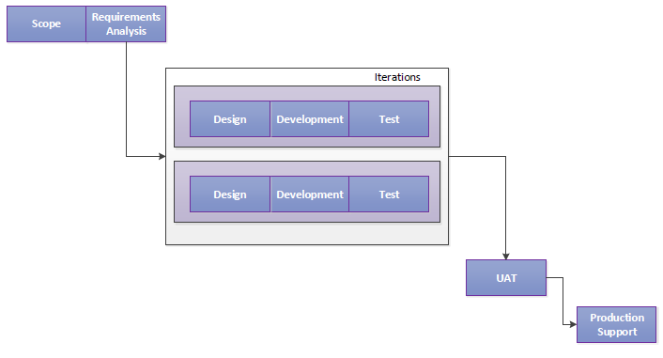

Requirements ->Iterations (Design, Development and Testing) -> UAT -> Deployment -> Post Production Support.

Need to refer to the traceability matrix document to identify test cases to be executed for the

functionality delivered per build/release.

1. QA Team analyzes and understands Business Requirements, and seeks Business Analysts for any clarifications needed.
2. Test Cases will be derived based on Business Requirements, Data mapping documents, Source & Target systems with below Database operations.
3. Below are Database operations are considering for testing purpose

|  |  |
| --- | --- |
| **Database Page** | **Operation** |
| Computer Page | Add a new Computer |
|  | Edit Computer |
|  | Filter by Name |
| Edit Computer Page | Save this Computer |
|  | Cancel |
|  | Delete this computer |
| Add Computer Page | Create this Computer |
|  | Cancel |

1. Test Cases will be populated based on the following scenarios and Test cases will be executed based on sampled test data and output data.
2. Traceability matrix document will be maintained to establish the traceability between Requirements, Test Scenarios, Test cases and defects.
3. Test cases will send for approvals to business analyst and Test Lead.
4. As soon as a build received from Development Team, QA will perform Smoke test to persist major data. The build will be rejected if it is not testable due to Urgent / High severity defects that cause most of the functionality not able to execute. If the build passed in Smoke Test, QA accepts the build and starts the detailed data integration testing.

### Data Validation Testing .

As part of Data Validation testing QA will perform these below testing activities.

* Validation of all data values in required format.
* Validation of all functionalities in system generated.

### Regression Testing

As part of Regression testing QA will perform these below testing activities.

* QA will verify the current functionality stays intact whenever new data are imported/Executed.
* QA will verify the new data updates have not broken any existing functionality
* If required, Test cases can be prioritized as per business risk and importance and then QA will retest those to store source data sets and results from successful runs of the code and compare new test results with previous runs.
* This can be achieved by validating comparison results using files.

## 4.3 Test Execution

**Software Build Sequences and Test Scope**

|  |  |  |
| --- | --- | --- |
| **Test Level** | **Build Frequency** | **Test to be conducted** |
| Sanity | Multiple times | TBD |
| Cycle-1 | TBD | Full cycle |
| Cycle-2 | TBD | Full cycle |  |  |  |
| Regression | Multiple times | Regression |  |  |  |

|  |  |
| --- | --- |
| **Type of Test** | Unit Test |
| **Objective** | To test the fitness of the build for testing |
| **Entry Criteria** | Development is complete  All major defects found in Code review fixed |
| **Exit Criteria** | All the Unit test cases pass  No major issues found |

|  |  |
| --- | --- |
| **Type of Test** | Smoke Test |
| **Objective** | To ensure the build given to QA Team to compare record counts between source data and target data are testable, and facilitate the QA to accept the build for further testing and QA team does not waste time installing and testing the software application |
| **Entry Criteria** | * Unit testing is complete. * All Urgent and High severity defects found in Unit Testing are fixed |
| **Exit Criteria** | All the smoke test cases pass.  No major issues found |

|  |  |
| --- | --- |
| **Type of Test** | Data Validation Testing |
| **Objective** | QA team validates data format with respect to srs document. |
| **Entry Criteria** | * Unit testing is complete * Data track release notes have been delivered and no critical * All Urgent and High severity defects found in Unit Testing are fixed * Smoke Test is successful |
| **Exit Criteria** | * All High and Medium priority Test cases are passed * All Urgent and High severity issues are fixed and closed |
| **Suspension Criteria** | Major functionality not working.  Many defects are found early in the cycle. |
| **Resumption Criteria** | All the identified issues are fixed.  Smoke Test successful. |

|  |  |
| --- | --- |
| **Type of Test** | Regression Testing |
| **Objective** | To ensure that current functionality stays intact whenever new code is released/changed. |
| **Entry Criteria** | * Smoke testing is completed.   Release notes have been delivered and no critical issues are open   * All Urgent and High severity defects found in Unit Testing are fixed * Exit criteria for Data validation have been met * Regression test cases are ready to execute * If applicable, Output results of previous run/test stored in spreadsheets are available for comparing with new run/test results |
| **Exit Criteria** | * The existing functionality of the system remains the same * All Urgent and High severity issues are fixed and closed * All testing issues informed and fixed / differed to next iteration/release or agreed to plan of action |
| **Suspension Criteria** | Major functionality not working.  Many defects are found early in the cycle. |
| **Resumption Criteria** | All the identified issues are fixed.  Functional Test successful. |

# RESOURCES

## Environment

|  |  |  |
| --- | --- | --- |
| **Test Environment** | | |
| Software | Hardware | |
| Compatible Browser(Chrome, I.E, Firefox, etc..) | VDI , 4GB RAM , Windows 7 | |
| Network environment | |  |
| Others (Please Specify) | |  |

**Tools**

|  |  |  |
| --- | --- | --- |
| **Tasks** | **Tools** | **Description** |
| Database Testing | SQL developer |  |
| Data Validation Testing | Manual |  |
| Defect Tracking | Track+ |  |
| Document Management System | Git |  |
| Test Cases Design, Execution and Reporting | Ms. Excel |  |

## Test Environment Diagram

Test Environment is a replica of Production Environment. The Application and server would be deployed and set at the client location and it would be accessed via URL. It is assumed that the Test/Production Environment contains the same configuration.

## Roles and Responsibilities

|  |  |  |  |
| --- | --- | --- | --- |
| **Role** | **Responsibility** | | **Name of the Resource** |
| Program Manager |  | * Review and approves Test Plan * Responsible for providing required support to QA team * Responsible for all aspects of project delivery, execution, and communication * Acts as the overall Solution Manager for the business for the project * Provides direction on project * Acts as the escalation point and primary contact for all project issues * Resolves project issues and helps mitigate risks | |
| Project Manager |  | * Review and approves Test Plan * Get required support for Testing activities, from Customer * Communicate changes in Business Requirements * Provides clarifications needed on Business Requirements * Communicate changes in Business Requirements | |
| Business Analyst |  | * Review and approves Test Plan & Test Scenarios * Review Test Cases and gives feedback * Interacts with business subject matter experts and conducts requirements gathering work sessions * Responsible for creation of the Business Requirement Document (BRD) * Responsible for the Systems Requirements Specification (SRS) | |
| QA Manager |  | * Business and System Requirements Analysis. * Estimates the QA Effort and Schedules. * Ensures the on time delivery of each release. * Ensures Quality of the product/services. * Prepares and maintains the Test plan, and executes the plan in the project cycle. * Reviews Test Scenarios and Test Cases. * Creates and submits Test Results and Summary Report. * Gets approval for all the Test artifacts from the stakeholders. * Manages and mentors QA resources. * QA Builds/Release Management and Builds Certification. | |
| QA Team |  | * Translate high level tasks to low level tasks and assist QA Manager in Estimating QA Efforts and Schedules. * Analyze and understand Business and System Requirements. * Assist QA Manger in Test Plan * Prepare and Review – Understanding documents, Test Scenarios, Test Cases, Functional Test Scripts, Performance Test Scripts, Traceability Matrix. * Perform Functional, Database, Web Services Testing * Defect Reporting and tracking defects to closure. * Review Test Results and Defects. * Create and submit Test Results and Summary Report. | |

# Schedule and Deliverables